CBOE
Test Plan
PITS 46843
SEDL 9265
The following test cases that a quote of 1.00 – 1.20 100 x100 has been entered for the test product. It also assumes that all floor trades entered are SELL side trades. Also, the floor trades must take place between two market maker roles. For example, in the test cases below trades were entered between NYM and DVS, both acronyms are market maker roles.

Test Case 1: Enter a Floor Trade (Carded Trade) 10@1.00

  - Login to your Trader GUI as a Market Maker role.
  - Enter a Quote on the product as mentioned above.
  - Use the Floor Trade Entry Window to submit a sell-side carded trade
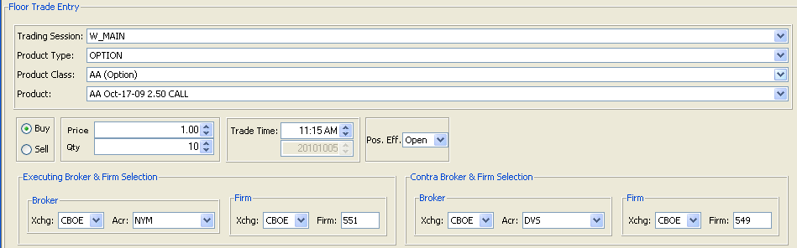

  - Verify in Market History Window that a Last Sale is submitted with no Prefix

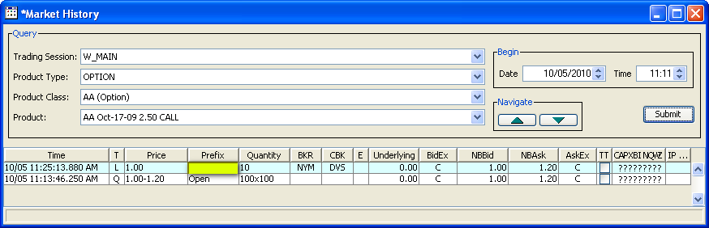

Test Case 2: Enter a Floor Trade (Carded Trade) 10@1.20

- Login to your Trader GUI as a Market Maker role.
- Enter a Quote on the product as mentioned above.
- Use the Floor Trade Entry Window to submit a sell-side carded trade
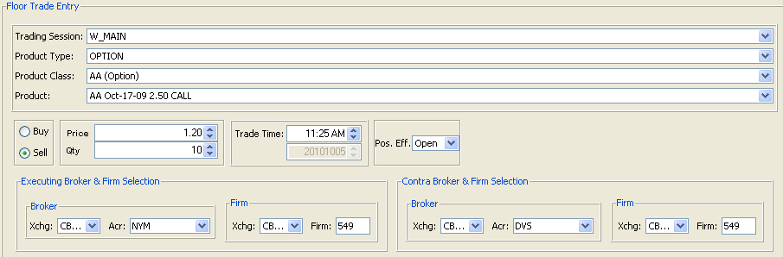

- Verify in Market History Window that a Last Sale of 1.20 is submitted with no Prefix
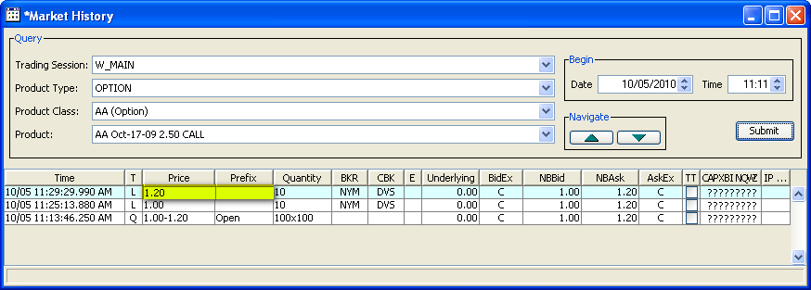

Test Case 3: Enter a Floor Trade (Carded Trade) 10@1.15

- Login to your Trader GUI as a Market Maker role.
- Enter a Quote on the product as mentioned above.
- Use the Floor Trade Entry Window to submit a sell-side carded trade
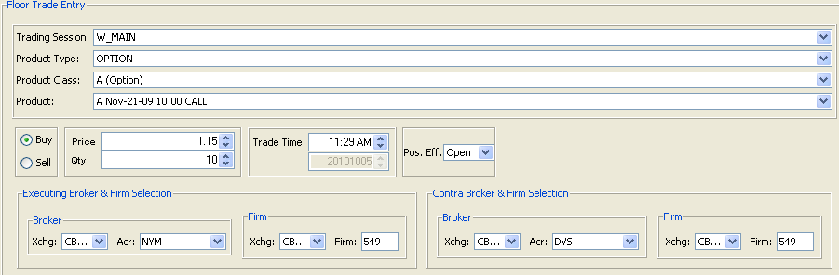

- Verify in Market History Window that a Last Sale of 1.15 is submitted with no Prefix
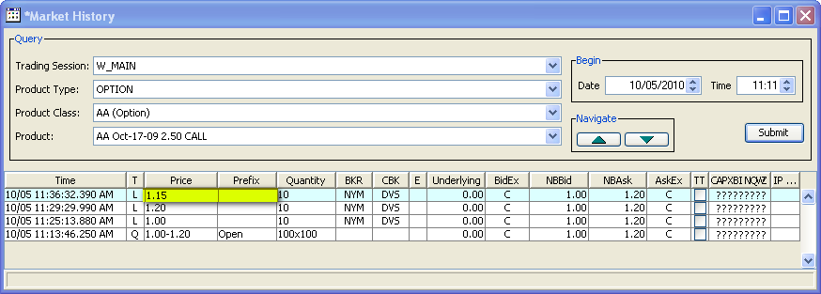

Test Case 4: Enter a Floor Trade (Carded Trade) 10@.90

- Login to your Trader GUI as a Market Maker role.
- Enter a Quote on the product as mentioned above.
- Use the Floor Trade Entry Window to submit a sell-side carded trade
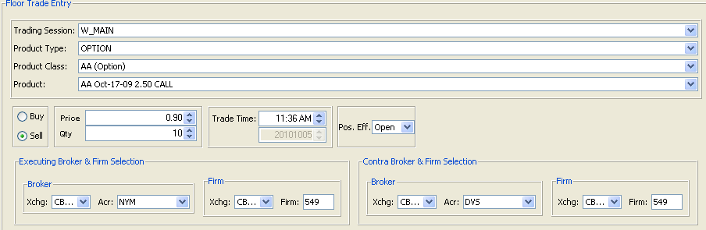

- Verify in Market History Window that a Last Sale of 0.90 is submitted with prefix OSEQ
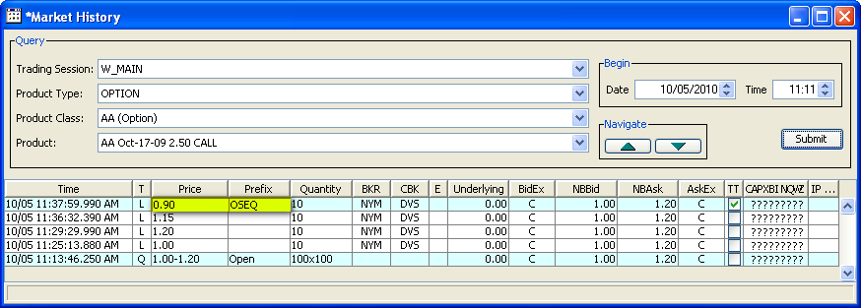

Test Case 5: Enter a Floor Trade (Carded Trade) 10@1.25

- Login to your Trader GUI as a Market Maker role.
- Enter a Quote on the product as mentioned above.
- Use the Floor Trade Entry Window to submit a sell-side carded trade
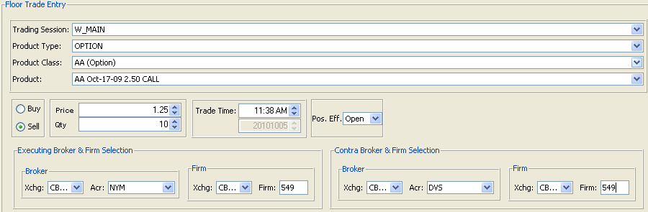

- Verify in Market History Window that a Last Sale of 1.25 is submitted with prefix OSEQ
